Grade 7 Accelerated · Unit 3 · Lesson 3  Exponential Expressions  Question Bank 3.03 | Name______________________  Date______________________  Period____________________

Show your work. Circle your final answer.
1. Two students evaluated 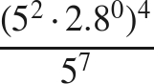. Patricia first wrote 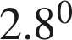 as 1, then 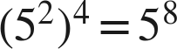, then 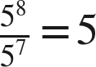. Kim first wrote 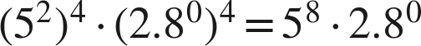, then , then .
a. Name the law Patricia used first, and the law she used second.

b. Name the law Kim used first.

c. Name the law both students used last, and give the value of the expression.

For questions 2 through 5, use the laws of exponents to evaluate. Show each law you use.
2. 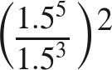

3. 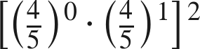

4. 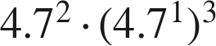

5. 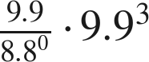

For questions 6 and 7, evaluate. Show each step.
6. 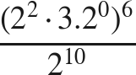

7. 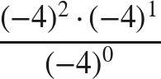

Equivalent or not.
8. Select ALL of the expressions that are equivalent to 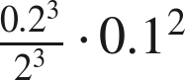.
□ A. 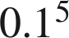
□ B. 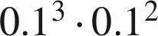
□ C. 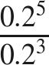
□ D. 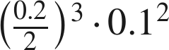
□ E. 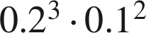
□ F. 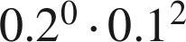

9. Which expression is equivalent to 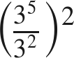 ?
○ A. 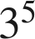
○ B. 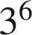
○ C. 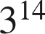
○ D. 

Working backwards.
10. Find the value of that makes each statement true.
a. 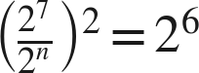

b. 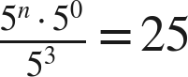

11. Ruth says that 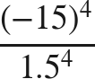 can be rewritten as 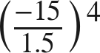 before evaluating. Is she right? Name the law, and give the value.

